Neurologists’ Role in Nazi “Racial Hygiene” Only Now Comes to Light
The killing and exile of “non-Aryan” members of the profession and collaboration of neurologists in eugenic and euthanasia efforts escaped scrutiny immediately after the war
- By Corinna Hartmann, Andreas Jahn on October 24, 2017

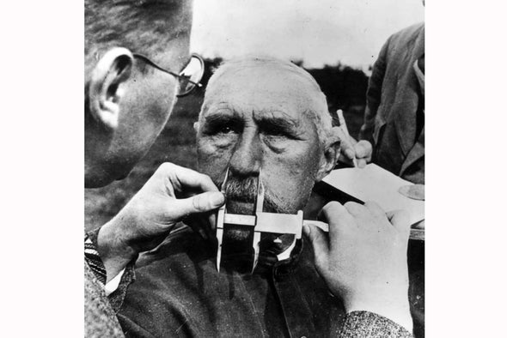

Medical historians have recently published accounts that show neurologists were indeed complicit with the Nazis—and became victims if they were classified as non-Aryan. Heiner Fangerau, who teaches the history and ethics of medicine at University Hospital Düsseldorf—along with colleagues Michael Martin at the Heinrich Heine University of Düsseldorf and Axel Karenberg from the University of Cologne—undertook extensive research on neurologists during the Third Reich for the German Society of Neurology. Fangerau discussed new findings with Corinna Hartmann and Andreas Jahn of Gehirn&Geist, the psychology and neuroscience specialty publication of Spektrum der Wissenschaft, and the German sister publication of Scientific American.
An edited transcript of the interview follows.

Professor Fangerau, your research project examines the role played by neurologists during the Nazi period. Why is this only happening 70 years after the fact?
There were several different phases in which people dealt with National Socialism after World War II. Immediately after 1945 the Allies pursued a policy of denazification. After that German society as a whole attempted to suppress its dark past. Many members of the next generation, however, found it impossible to close their eyes: Students in the 1968 movement were angry that their parents were unwilling to deal openly with the Third Reich. The medical specialties took even longer to begin working through the past. As a result, their reappraisal of the crimes committed began only in the 1980s. Part of the reason why historical research into neurology has only been conducted systematically over the past several years is that neurology and psychiatry were forced into the same disciplinary framework in 1935. Before then neurology had begun to separate from psychiatry. The basic idea was to leave psychological phenomena that are difficult to understand to the psychiatrists and to concentrate on disorders that are anatomically demonstrable. The National Socialists nullified this effort. They believed that they could control these medical specialties more effectively if they brought them together in the Society of German Neurologists and Psychiatrists, which was dominated by psychiatrists committed to the ideology of racial hygiene. The chairman of the society was Ernst Rüdin, a psychiatrist. As a result, neurology has come to be viewed as less implicated. Historical research conducted since the late 1980s, however, paints a very different picture.

What are the most important findings of your research?
Neurology as a discipline was indeed complicit in the crimes of the Nazis. The ideology of racial hygiene combined with opportunistic arguments about compassion and cost reductions served to justify the systematic killing of more than 70,000 disabled and sick people. The Nazis euphemistically called this policy euthanasia. Both neurologists and psychiatrists were involved, and it is often difficult to distinguish who was a neurologist and who was a psychiatrist. The doctors assessed patients, and whoever they found to be either problematic or incapable of working was transferred to a killing facility and murdered. Neuroscientists then used the brains of these murdered patients in their research.

What did you find especially shocking?
I found especially frightening the matter-of-factness with which many physicians used the bodies of those who had been killed, and their indifference in carrying out or approving experiments on their patients. After the war these crimes in the name of science were covered up as the acts of individuals. But in fact, these were by no means the acts of sadistic individuals; rather, a large proportion of academic neurologists collaborated with the Nazi system to their mutual benefit. The scientists were the recipients of research projects and state funding, and in return the National Socialists received scientific legitimation for their racial policies. Under the Nazis physicians were to play a major role in the state. And unfortunately, on the whole, physicians were prepared to work with the regime.

What sorts of research did neurologists conduct back then?
For one thing, they studied diseases like epilepsy. Their main concern here was to distinguish between hereditary and nonhereditary forms so that patients with a genetic predisposition could be forcibly sterilized in accordance with Nazi eugenic principles. The second research focus was brain anatomy. Using samples from those who had been euthanized, neurologists studied the structure, function and pathology of the brain.

What happened to the samples and the knowledge derived from them after 1945?
The findings of these inhumane studies were simply merged into further research during the postwar era. The brains and preserved tissue such as the brain sections of euthanasia victims largely remained at the institutes where they continued to be used as material for studies. For example, the German Research Institute for Psychiatry, now the Max Planck Institute of Psychiatry in Munich, housed a large anatomical collection. Researchers in the history of medicine are currently doing research on these specimens. Apparently, for many years scientists were unable to resist the lure of working with these ghastly remains. It took persistent pressure from journalists and historians, especially from Israel, before German anatomical collections were systematically examined for incriminated material. In the 1990s many of these samples were removed from the archives and buried. It should be noted, however, that such mass burials are not unproblematic from today’s perspective, because it has made it even more difficult to identify the people who were murdered. It is one of the goals of research into this history to return to victims who were given numbers their true identities.

Which neurologists were especially complicit in the crimes of the National Socialists?
The most prominent were the neuropathologist Hugo Spatz and the brain researcher Julius Hallervorden. Both worked at the Kaiser Wilhelm Institute for Brain Research in Berlin. Under Spatz’s leadership the institute became a hotbed of eugenics. As head of the histopathology department, Hallervorden conducted “secondary research” for the euthanasia program on the diseases suffered by the patients who were killed. Among other things, he and his co-workers studied which neurological and psychiatric diseases are hereditary. These determinations formed the basis for the selection of patients to be killed. The Kaiser Wilhelm Institute received large numbers of brains of euthanasia victims for its research. And as we now know, those who took part in that research were well aware of their origin.

After the fact, how do you determine who was a true believer in the Nazi cause and who was merely a follower?
In point of fact, it is not always as clear as in the case of Hugo Spatz and Julius Hallervorden. For example, Heinrich Pette, who headed the Neurology Department of the Society of German Neurologists and Psychiatrists, has never been linked to the euthanasia program. If we want to know whether a particular person was complicit with the Nazi system, we could of course ask: Was he or she a member of a National Socialist organization? But that would be an oversimplification because many people became members of the Nazi Party without acting on its behalf. That is why we also look at the date on which they joined. For example, did the person join the party before 1933 or after the seizure of power? Or was he or she someone who applied for membership after it stopped accepting members? Other important considerations include personal contacts with Nazi functionaries, appearances at political events, publication in Nazi periodicals and the denunciation of co-workers. Pette took the stage at important Nazi-sponsored events and frequently expressed the racial policies of the day. But it is not yet clear whether he betrayed colleagues—or perhaps may even have protected them.

https://www.scientificamerican.com/article/neurologists-role-in-nazi-racial-hygiene-only-now-comes-to-light/

